**Naan Mudhalvan Phase V Assessment**

Course Name: Internet of Things

Team Name : Techspark

Project Title: Public Transportation Optimization

Team Members :

|  |  |  |
| --- | --- | --- |
| **Name** | **Register number** | **NM ID** |
| **Praveen U S** | 721221106069 | au721221106069 |
| **Sanjay S** | 721221106088 | au721221106088 |
| **Sankar Maharajan G** | 721221106090 | au721221106090 |
| **Murugesan M** | 721221106303 | au2272120025 |

**Project Title: Public Transportation Optimization**

**Objective**

The Public Transportation Optimization project has been initiated to address the challenges faced by passengers who use public transportation services. The project aims to enhance the quality of bus services by monitoring the real-time location, temperature, and humidity of buses. By doing so, it ensures that passengers have a comfortable and safe journey.

A website has been created to provide passengers with access to this information. Passengers can now track the location of buses, as well as the temperature and humidity inside them. This information enables passengers to plan their journey better and make informed decisions, ensuring a smooth and stress-free travel experience. Additionally, the website allows passengers to report any issues they face during their journey, which helps bus operators to improve their services.

By implementing this project, public transport services will become more efficient and reliable, and commuters will experience better and more comfortable travel. The optimized routes will take into account factors such as traffic conditions, passenger demand, and service frequency, ensuring that the routes are efficient and effective. The fixed schedule of public transport will enable people to plan their journey and arrive at their destination on time without worrying about waiting for public transport.

**IoT Sensor Deployment**

**Sensors Used:**

1. **GPS Module:** This sensor provides real-time location data for each bus in the fleet.
2. **Temperature and Humidity Sensors:** These sensors monitor the environment inside the bus, enabling passengers to know the current temperature and humidity levels.

**Sensor Deployment:**

The GPS module and temperature and humidity sensors are deployed on each bus, ensuring real-time data collection. These sensors are connected to data processing units within the bus.

**Architecture**

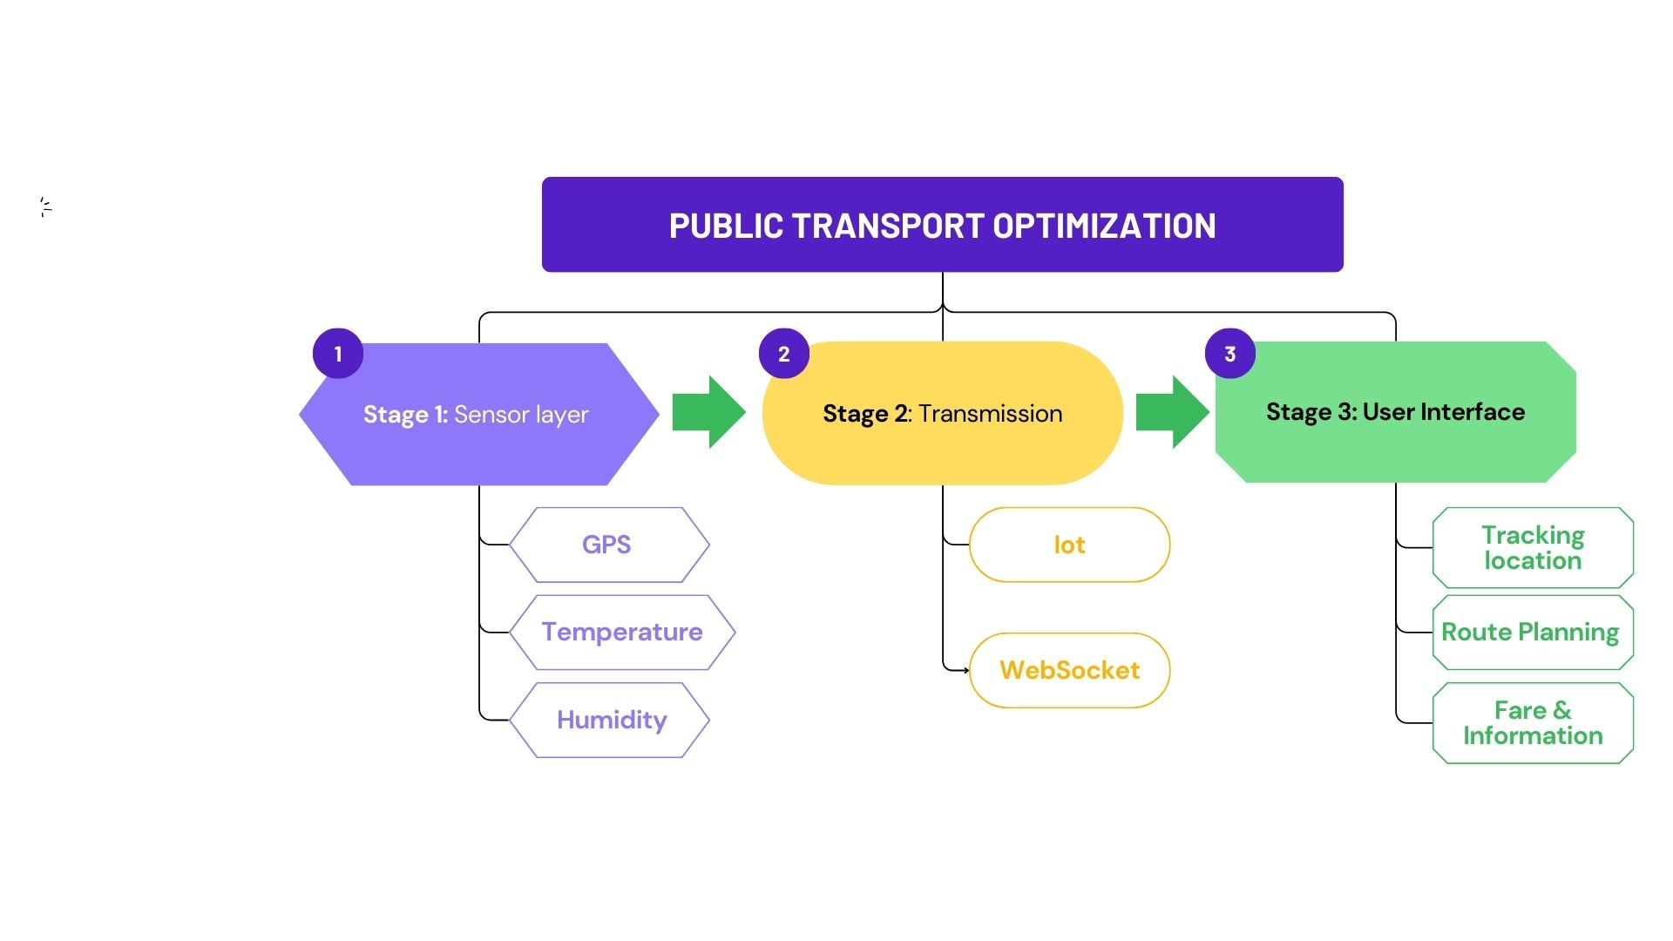

**Platform Development**

**Server Infrastructure:**

The project utilizes a server infrastructure hosted on a chosen cloud platform, such as IBM Cloud. This infrastructure is responsible for data storage and processing, ensuring real-time information availability.

**APIs and Databases:**

The project incorporates APIs for data ingestion and storage, and it employs a suitable database (MYSQL) for data storage. Detailed information about the data schema and database design is provided.

**Code Implementation:**

The codebase is built using a combination of programming languages and frameworks, including **React JS and Django Framework**. It handles both the Front end and back end of the webpage. Code snippets demonstrate essential features like sensor data collection, data processing, and real-time data transmission.

**Real-Time Data Display**

**Web Interface:**

A user-friendly website has been created to display real-time transit information. The website's interface allows users to access the following data:

1. **Location Tracking:** Users can view the real-time location of buses, It displays estimated arrival of transport ,enhancing their ability to plan routes and reduce waiting times.
2. **Temperature and Humidity Information:** Passengers can access real-time temperature and humidity data inside the buses, ensuring a comfortable and safe environment.

**Data Integration:**

The real-time data from sensors and the transit information platform is seamlessly integrated, ensuring that the website displays accurate and up-to-the-minute data. This is achieved through continuous data updates and the use of appropriate communication protocols such as WebSocket or server-sent events (SSE).

**Project Benefits**

**The real-time transit information system provides several key benefits:**

1. **Enhanced Passenger Experience:** Users can make informed decisions about their public transportation choices, resulting in shorter wait times and improved overall comfort during their journey.
2. **Improved Safety:** Real-time monitoring of temperature and humidity helps maintain a safe and comfortable environment inside the buses.
3. **Efficient Communication:** The platform facilitates efficient communication by notifying passengers and system administrators about relevant updates and alerts.

**Submission**

**GitHub Repository:**

The GitHub repository, where the project's code and associated files are hosted, has been organized in a way that makes it easy for others to understand and replicate the project. The repository includes well-structured README files and detailed documentation that provide clear instructions and explanations, making it straightforward for anyone to follow along and contribute to the project.

My GitHub repository link: <https://github.com/SANJAY-S-KIT/Public-Transportation-Optimization.git>

**Replication Instructions**

Detailed instructions are provided for replicating the project, including the following steps:

1. Deployment of the GPS module, temperature, and humidity sensors on buses.

2. Development of the transit information platform.

3. Integration of the sensors and platform to ensure accurate real-time data display on the website.

4. Local or cloud deployment of the project.

**Example Outputs**

Screenshots and visual examples are included to demonstrate:

Simulation output of our project:

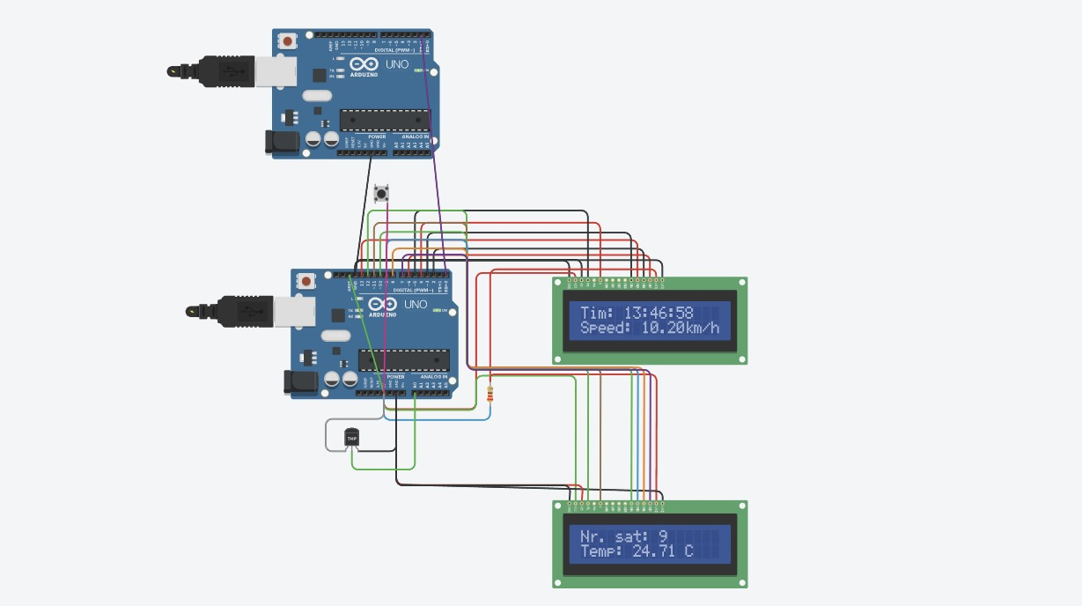

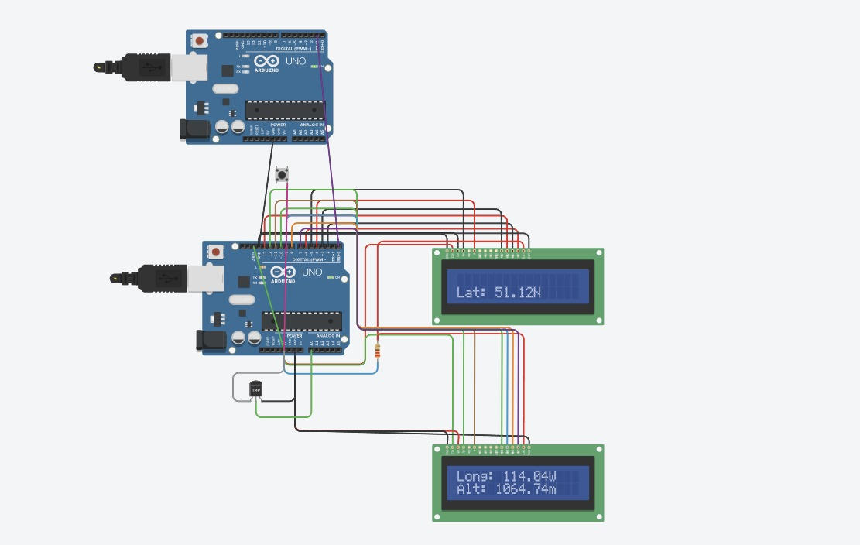

User interface of the website, including real-time data updates.

Home Screen of our Webpage:



Login Screen:



User Dashboard:

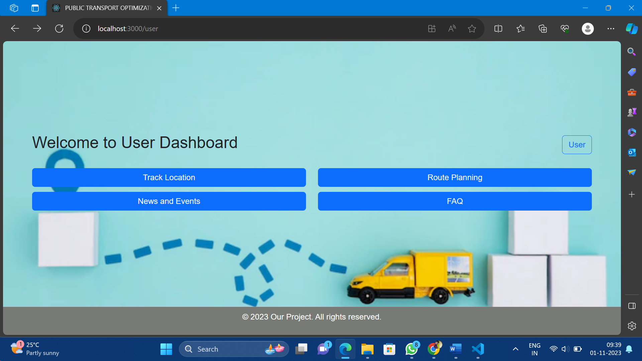

Track Location Screen:

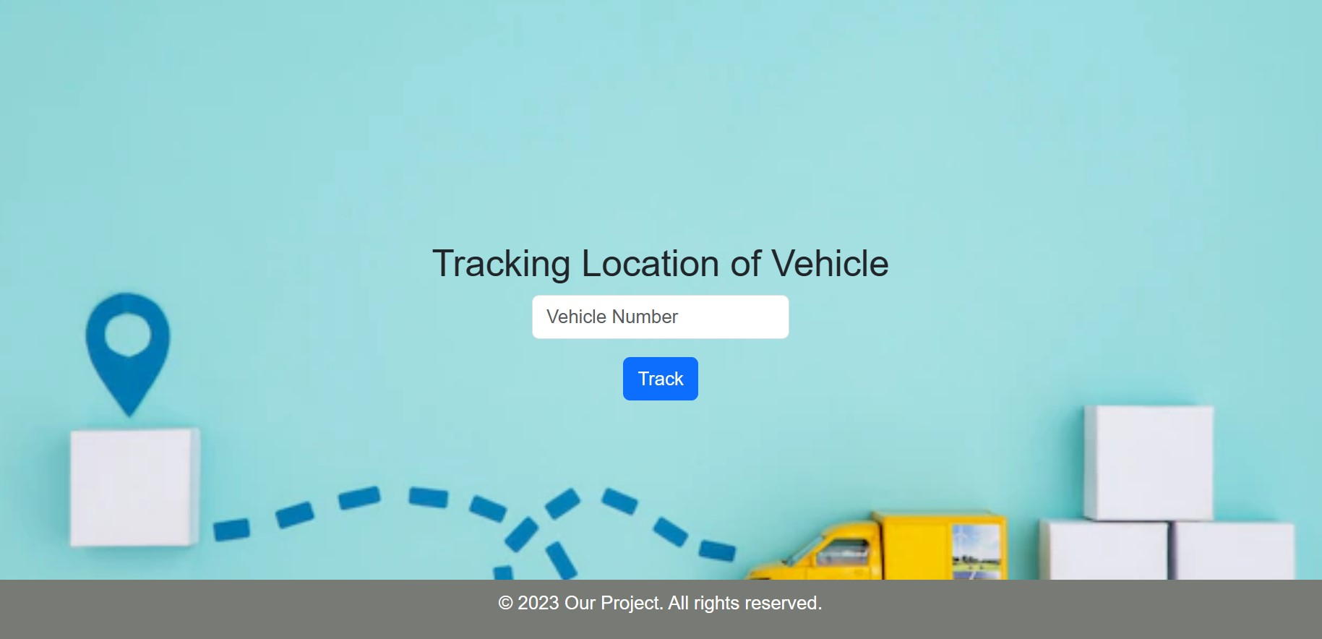

Output: 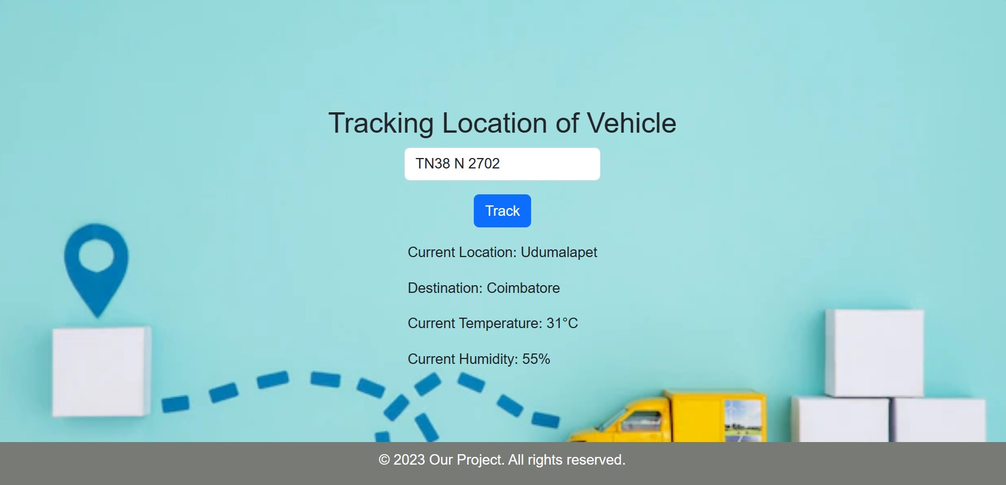

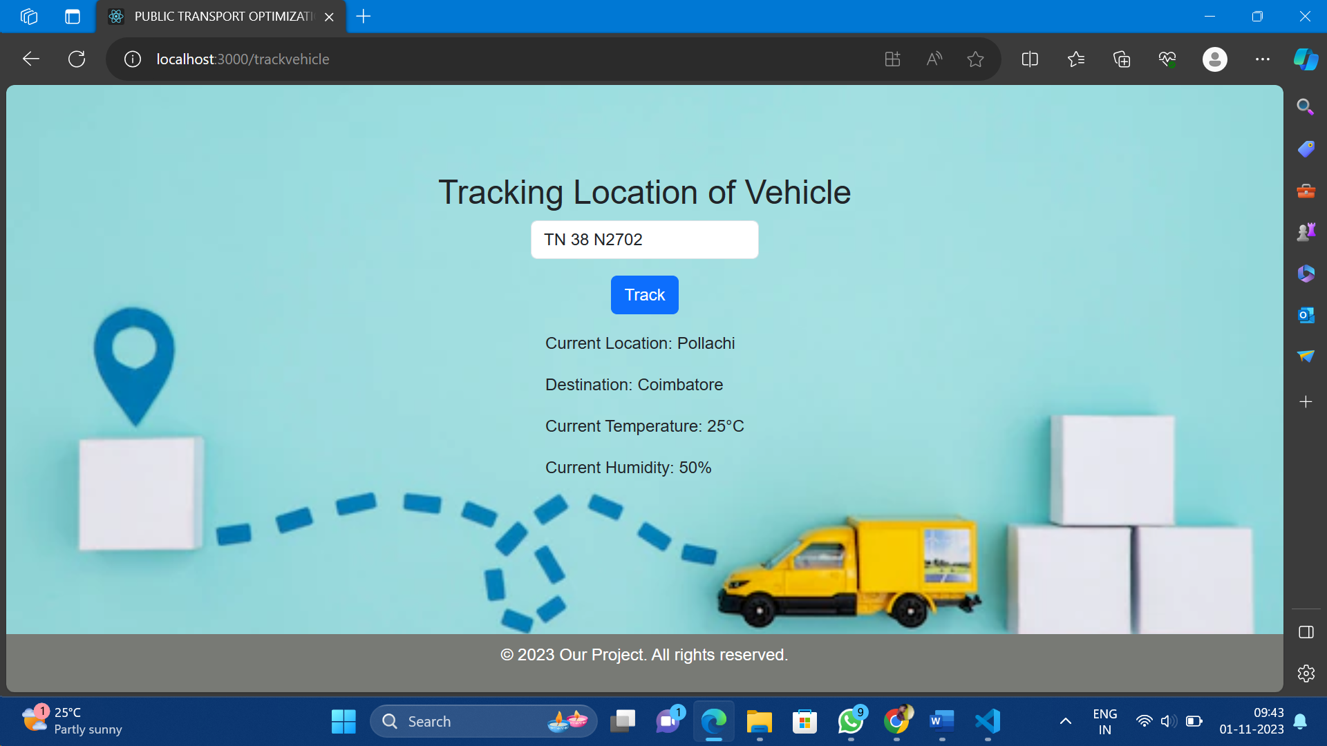

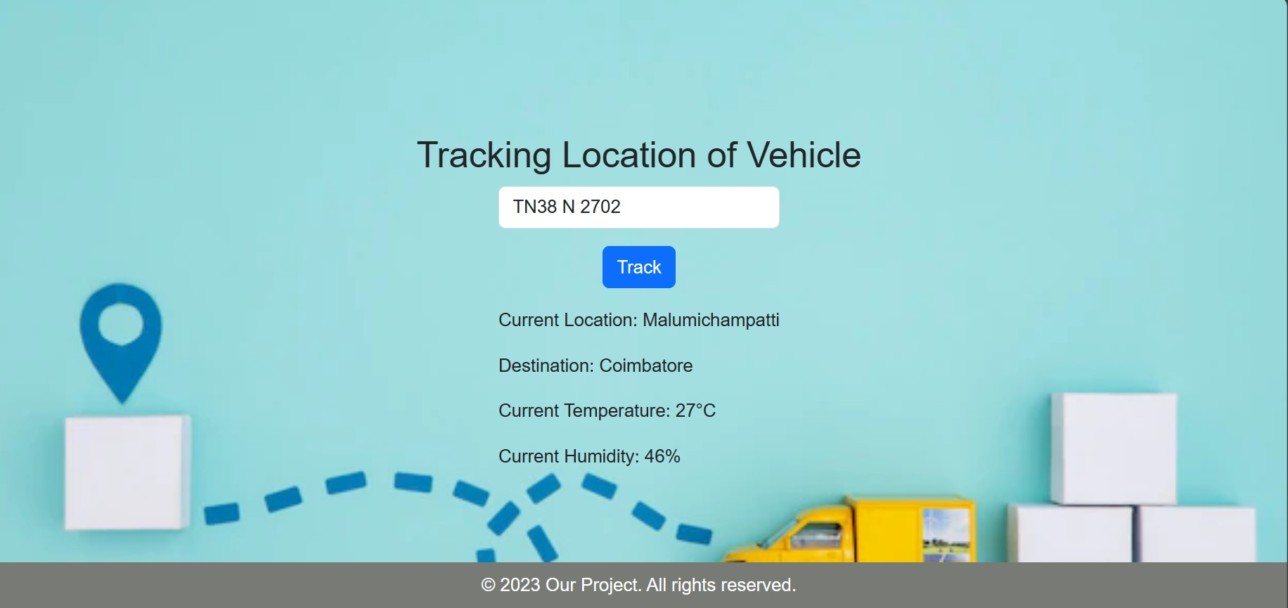

**Conclusion :**

In conclusion, the "Public Transportation Optimization" project represents a significant advancement in improving the quality and efficiency of public transportation services. By deploying GPS modules, temperature, and humidity sensors on buses and creating a user-friendly website for real-time data access, this project addresses key challenges faced by both passengers and public transportation operators.

The deployment of GPS modules enables passengers to track bus locations in real-time, empowering them to plan their journeys more effectively and reducing waiting times. Simultaneously, the inclusion of temperature and humidity sensors ensures that passengers travel in a safe and comfortable environment, with real-time access to environmental conditions.

The development of the transit information platform and the integration of sensors and data through Python-based APIs result in a seamless flow of real-time information to the website's user interface. This real-time data display serves as a valuable tool for passengers to make informed decisions and experience more convenient and pleasant journeys.